About this document

* Client: Kitbag – Real Madrid Official Online Store
* Project: Multilingual CRO project
* Prepared by: Lynne Wright
* Date: 30 January 2014

Sections

1. About the project 2

1.0 Background 2

1.1 Next steps: 2

1.2 Deliverables & dates 2

2. JPG brief 3

2.0 Requirements 3

2.1 Overview of the wireframes 3

2.2 Approved copy 4

2.3 Design requirements 5

2.4 Deadline 5

3. Product page experiment 6

3.0 Requirements 6

3.1 Overview of the product page wireframe – Home & Away kits 6

3.2 Overview of the product page wireframe – Third kit 7

3.3 Overview of the lightbox wireframe 7

3.4 Approved copy 8

3.5 Experiment set up 10

3.6 QA 11

3.7 Deadline 11

4. Homepage experiment 12

4.0 Requirements 12

4.1 Overview of the wireframe 12

4.2 Approved copy 12

4.3 Experiment set up 13

4.4 QA 14

4.5 Deadline 14

5. Appendices 15

5.0 Appendix 1 – UK Homepage wireframe 15

5.1 Appendix 2 – Spanish Homepage wireframe 16

5.2 Appendix 3 – Chinese Homepage wireframe 17

5.3 Appendix 4 – Product page wireframe 18

5.4 Appendix 5 – Lightbox wireframe 19

1. About the project

## Background

We are working on a multilingual CRO project for Kitbag on the Spanish, Chinese and English versions of their [Real Madrid official online store website](http://www.realmadridshop.com/stores/realmadrid/default.aspx). We have proposed two split tests on the website.

So far, we have run a number of usability studies, collated the findings, identified the experiments we wish to run and proposed these to Kitbag (these are an experiment on the product pages for men’s shirts and one on the homepage). Wireframes have been created (see appendix) and these have been shown to the usability testers for feedback.

## Next steps:

The next steps of this project are:

1. To create JPG designs for each of the homepage tests for further usability feedback (brief in section 2)
2. To create the product page experiment in Optimizely (brief in section 3)
3. To create the homepage experiment in Optimizely (brief in section 4)

## Deliverables & dates

We are aiming to work to the following timescales

|  |  |  |
| --- | --- | --- |
| Deliverable | | Date |
| 1 | 3 JPG designs for the homepage test (English, Spanish and Chinese versions)  **Note:** No JPGs are required for the product page test | **ASAP** – further usability feedback sessions scheduled for next week |
| 2 | Development of the product page experiment in Optimizely | To be developed, tested and signed off **by Fri 7 Feb**  (experiment to be launched by Tue 11 Feb) |
| 3 | Development of the homepage experiment in Optimizely | To be developed, tested and signed off **by Fri 21 Feb**  (experiment to be launched w/c 24 Feb once product page experiment has reached significance) |

1. JPG brief

## Requirements

Wireframes have been created for the changes on the [homepage](http://www.realmadridshop.com/stores/realmadrid/default.aspx). See Appendix 1, 2 & 3.

JPG designs of these wireframes are required to get further user feedback on them before we develop the Optimizely test.

**Note**: These designs need to be as close to the wireframes as possible as a lot of work has gone into making these suitable for the users. The style of the Real Madrid website must also be followed.

## Overview of the wireframes

On the wireframes the following elements have been added/amended

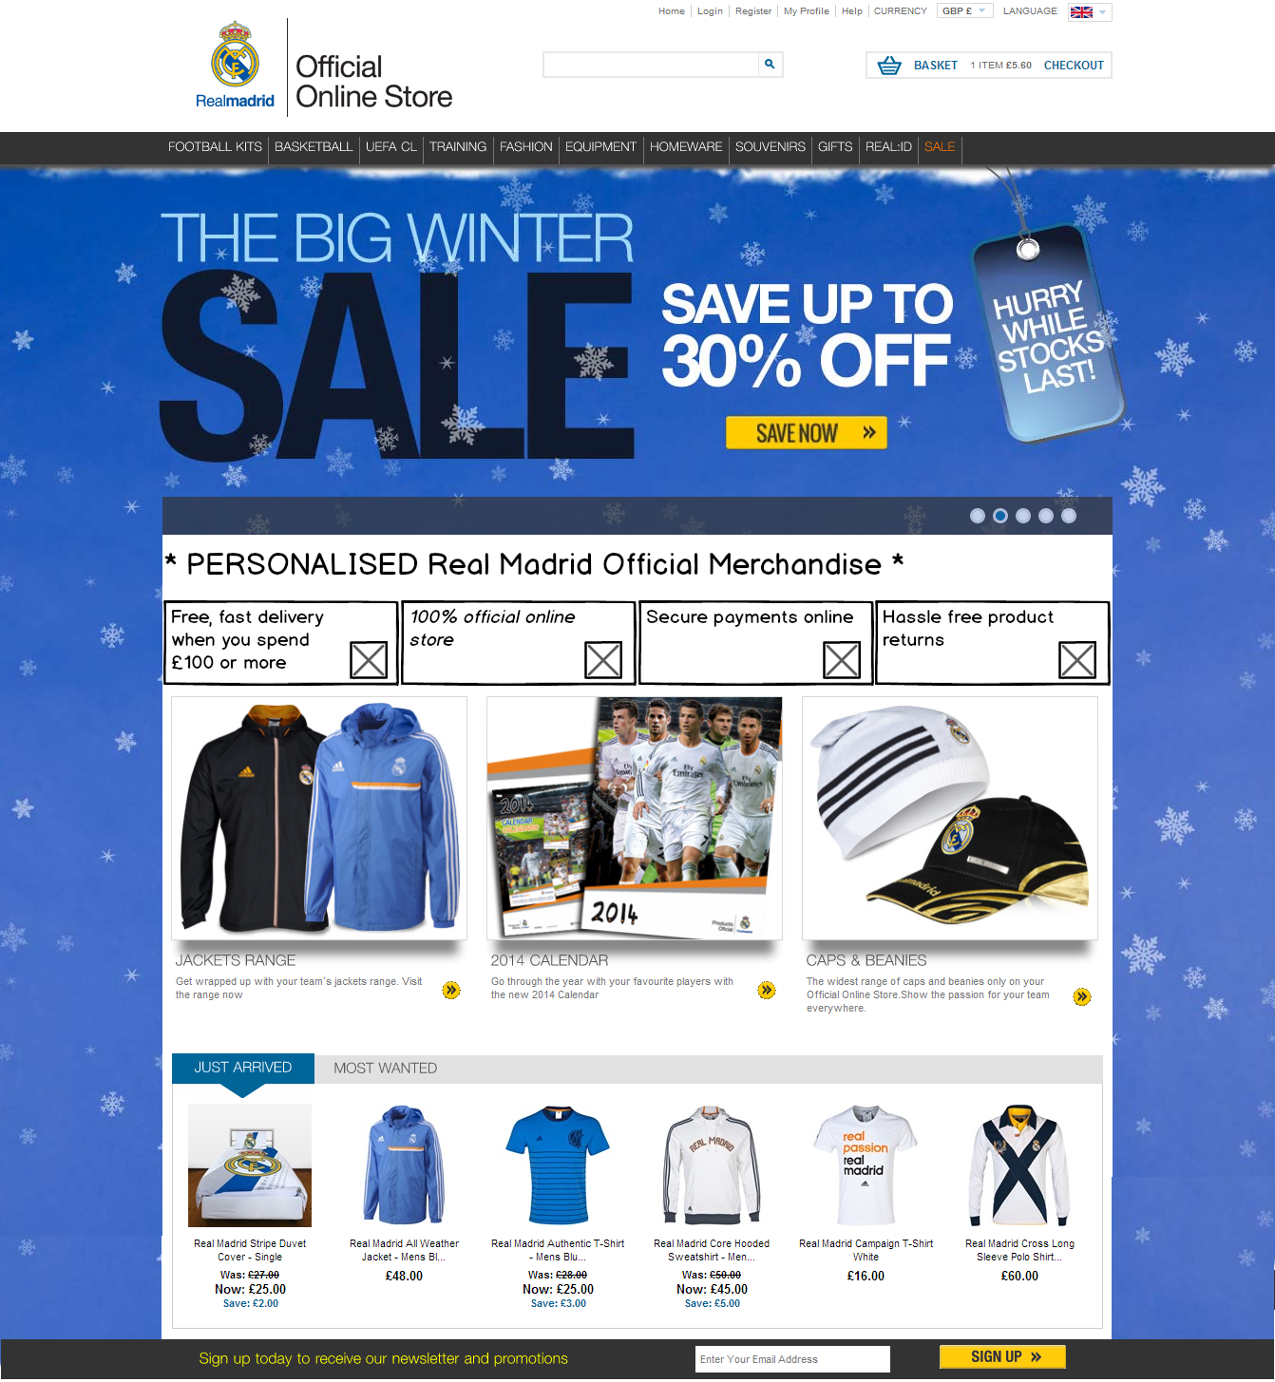

**AMENDED**: Added a fourth box to the current 3 box image. (see below)

Increased the depth of this image and used larger icons

Changed some of the content

**ADDED**: a value proposition headline

**Current three box images:**

* English site



* Spanish site:



* Chinese site:



## Approved copy

The approved copy for each language is as follows: (Note that some of these have changed from the wireframe to incorporate user feedback)

### English

|  |  |  |
| --- | --- | --- |
| Element | Copy | Design / icon |
| Headline | PERSONALISE Real Madrid Shirts, Shorts and Socks | Include a visual element (such as stars) at the start and end of the copy to draw attention to it.  Possibly also include an image of the back of a personalised shirt to provide context  Should link to the [Football Kits](http://www.realmadridshop.com/stores/realmadrid/products/product_browse.aspx?category%7ccategory_root%7c8536=Football%20Kits) page (but not visually look like a link) |
| Box 1 | FREE, FAST DELIVERY WHEN YOU SPEND £100 OR MORE | Delivery truck. Examples [here](http://www.istockphoto.com/stock-illustration-33633978-shopping-icons-set-vector.php?st=47146a7) & [here](http://www.istockphoto.com/stock-illustration-13640562-mini-van-icon.php?st=47146a7) |
| Box 2 | 100% OFFICIAL ONLINE STORE | As per/similar to current site |
| Box 3 | SECURE PAYMENTS ONLINE | As per/similar to current site |
| Box 4 | HASSLE FREE PRODUCT RETURNS | As per/similar to current site |

### Spanish

|  |  |  |
| --- | --- | --- |
| Element | Copy | Design / icon |
| Headline | AMPLIA GAMA – más de 800 productos | Include a visual element (such as stars) at the start and end of the copy to draw attention to it (copy translates to VAST RANGE – over 800 products) |
| Box 1 | 10% DE DESCUENTO EXTRA – regístrate gratis | To represent money off/saving – i.e the % star icon [here](http://www.google.co.uk/imgres?sa=X&espvd=210&es_sm=122&biw=1360&bih=643&tbm=isch&tbnid=L5uv5uzvhi3rvM%3A&imgrefurl=http%3A%2F%2Fgraphicriver.net%2Fitem%2Fshopping-on-internet-black-icons-set-with-shadow%2F3000228&docid=QsW75Monp6eVoM&imgurl=http%3A%2F%2F2.s3.envato.com%2Ffiles%2F34503516%2Fshopping-glossy-icons-set-prev.jpg&w=590&h=590&ei=mRvpUo3PB6jP0AXnzICQBA&zoom=1&ved=0CPMBEIQcMDE&iact=rc&dur=1103&page=3&start=38&ndsp=23) (copy translates to EXTRA 10% discount – sign up for free) |
| Box 2 | ENVíOS GRATIS A ESPAÑA EN COMPRAS SUPERIORES A 80€ | Delivery truck as per UK site box 1  (copy translates to Free delivery to Spain on orders over $) |
| Box 3 | ENVíOS A ESPAÑA POR SÓLO 4.95€ | Delivery truck as per UK site box 1  (copy translates to Delivery to Spain for only $) |
| Box 4 | ENVíOS EXPRÉS A ESPAÑA POR SÓLO 11.95€ | Delivery truck as per UK site box 1  (copy translates to Express delivery to Spain for only $) |

### Chinese

|  |  |  |
| --- | --- | --- |
| Element | Copy | Design / icon |
| Headline | 100%官方商品。欧洲正品。 | Include a visual element (such as stars) at the start and end of the copy to draw attention to it (copy translates to 100% Official Merchandise. Authentic European.) |
| Box 1 | 为成千上万的中国球迷所信赖 | A trust symbol or a tick as per the UK site   (copy translates to Trusted by thousands of Chinese fans) |
| Box 2 | 接受支付宝付款 | An [AliPay logo](https://www.google.co.uk/search?q=alipay+logo&espv=210&es_sm=122&source=lnms&tbm=isch&sa=X&ei=XxrpUvLIBYz0yAP52IHgCg&ved=0CAcQ_AUoAQ&biw=664&bih=615)  (copy translated to Alipay payment is accepted. AliPay is a common Chinese payment option) |
| Box 3 | 网上支付安全保障 | As per/similar to current site   (copy translates to secure payments online) |
| Box 4 | 退换货无烦恼 | As per/similar to current site   (copy translates to hassle-free product returns) |

## Design requirements

It is worth noting that one of the English user testers who saw the wireframe commented that he thought that this was a headline for the entire promo box so there needs to be some visual separation between this new feature (headline & 4 boxes) and the product promotions below. This could be something visual in the design or adding a section title above the product promotions. (Translation will be provided if required)

**Important**: this was particularly relevant in the case of the English wireframe as the tester assumed that the products promoted below were available for personalisation, when actually it’s only shirts, shorts and socks. As the other headlines didn’t mention anything product-specific such as personalisation, then this was less relevant. (the English headline has since been changed to be more specific, but the visual separation is still a design requirement)



Note this copy has since been changed, but visual separation is still required.

Visually separate

## Deadline

We have scheduled follow up sessions with the Spanish, Chinese and English usability testers for next week so the sooner these are developed the better.

1. Product page experiment

## Requirements

To set up three experiments in Optimizely:

1. The Men’s shirts product pages on the English site
2. The Men’s shirts product pages on the Spanish site
3. The Men’s shirts product pages on the Chinese site

A brief overview of the changes we are testing are:

* Content & design changes to the ‘Personalise your kit’ section to make it more intuitive how to use it (see sections 3.1 & 3.2 and appendix 4)
* Adding a help tip which opens a newly created lightbox (see sections 3.3 and appendix 5)
* Alphabetising the content in the ‘Squad list’ dropbox to improve usability (which is currently poor as names are in a seemingly random order)

Each experiment will have two variations, the original and our variation (English wireframes below – the Spanish and Chinese wireframes follow the same design with translated copy).

## Overview of the product page wireframe: Home, Away & both Goalie kits

On the wireframes the following elements have been added/amended/removed

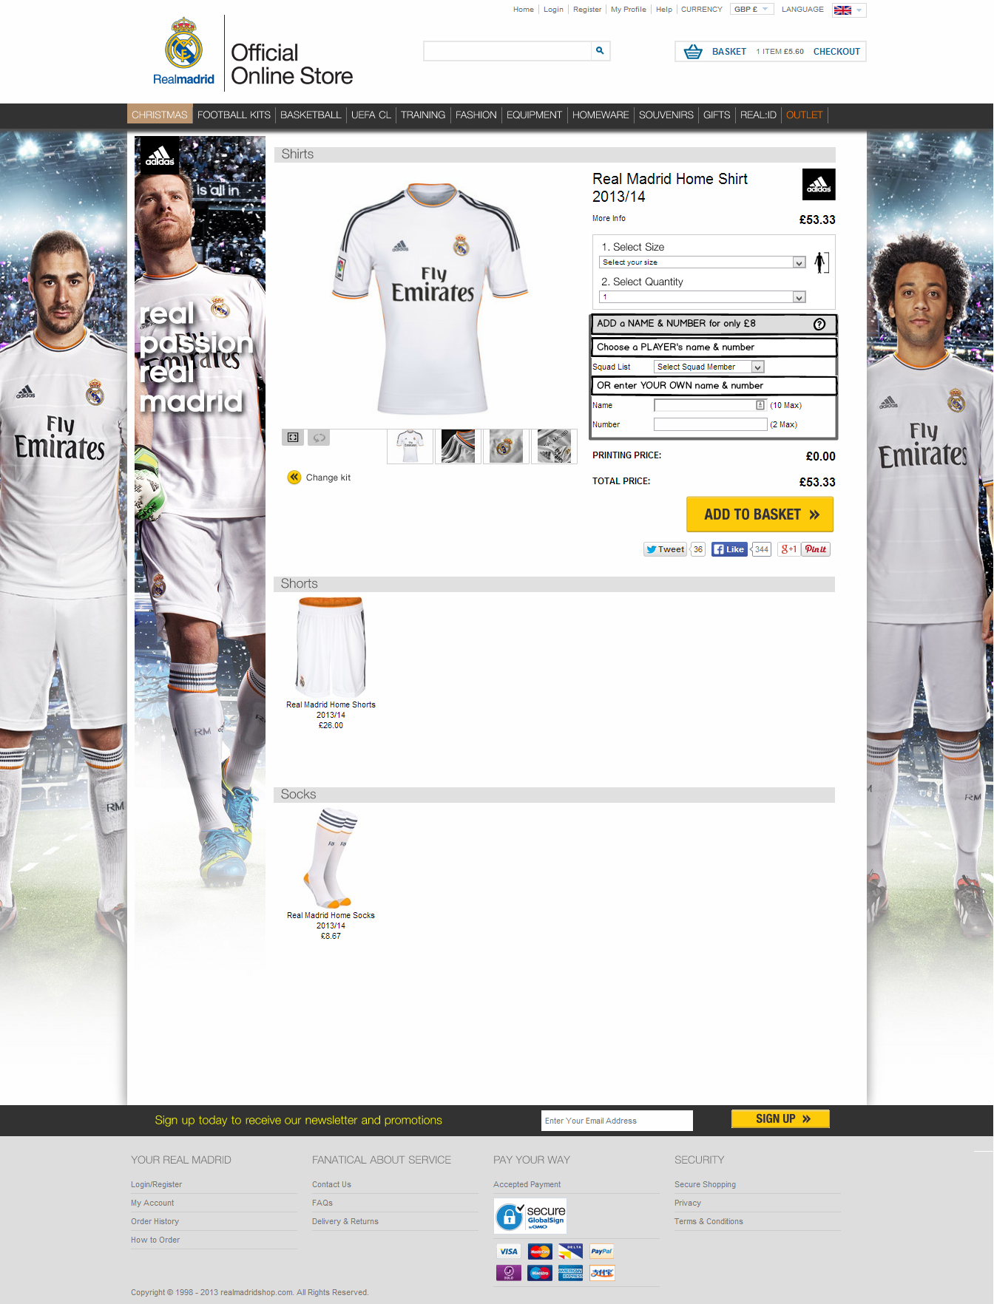

REPLACED: ‘Personalise your kit’ header with a Name/Number header

ADDED: Player’s name instruction

AMENDED: Alphabetise list

ADDED: Your name instruction

ADDED: Help icon (opens lightbox)

REMOVED: ‘Printing disclaimer’ link (has been replaced by help icon)

## Overview of the product page wireframe: Third kit

This is slightly different to the first kit as it also includes the option of having the UEFA badge. I am hoping this can still be part of the same experiment though.

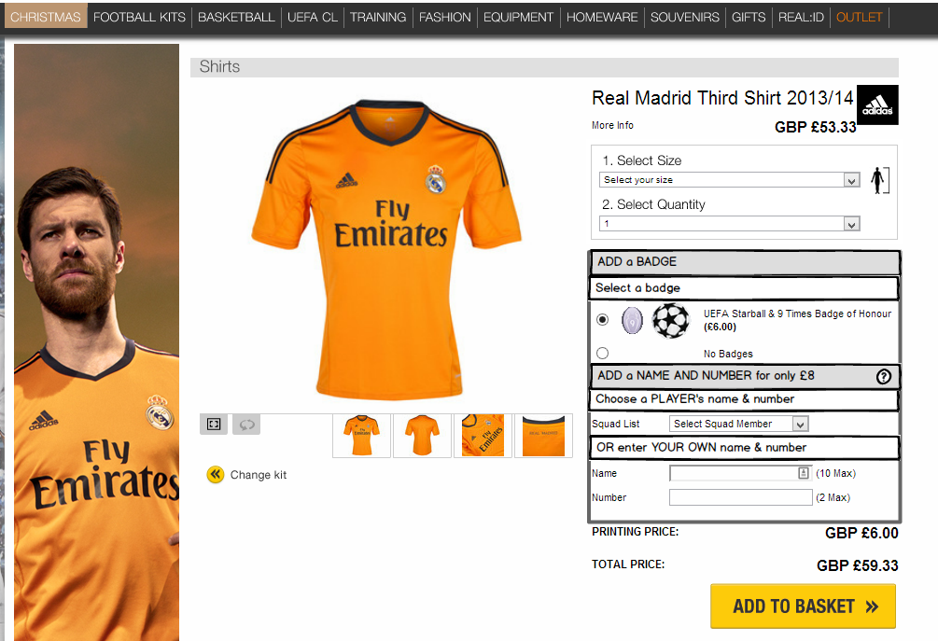

AMENDED: Alphabetise list

REPLACED: ‘Personalise your kit’ header with a Badge header

ADDED: Badge instruction

ADDED: Name/Number header

ADDED: Player’s name instruction

ADDED: Help icon (opens lightbox)

REMOVED: ‘Printing disclaimer’ link (has been replaced by help icon)

ADDED: Your name instruction

## Overview of the lightbox wireframe

This lightbox is to open when a user clicks the help icon

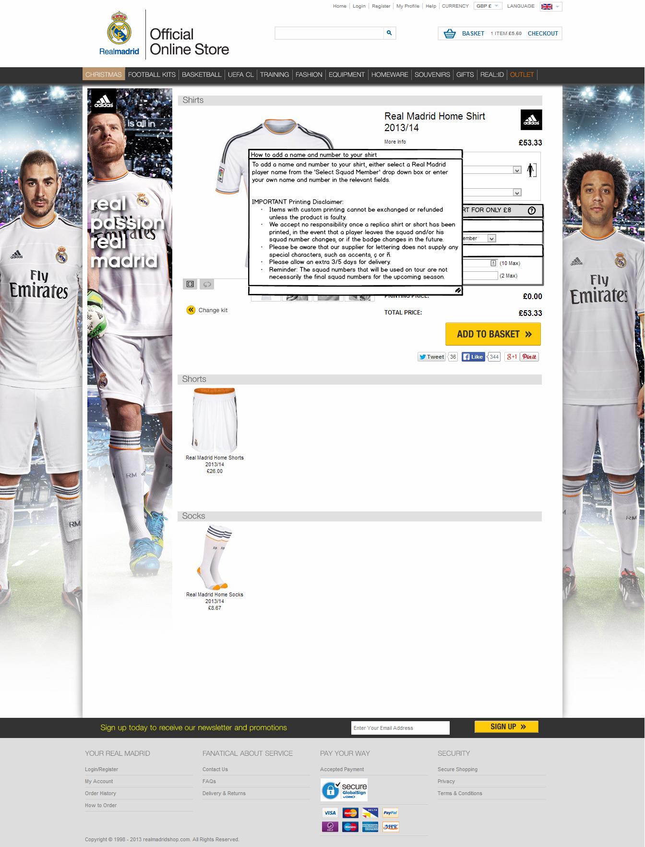

Lightbox content

Lightbox title

Needs to include a close icon

## Approved copy

### English

|  |  |  |  |
| --- | --- | --- | --- |
| **Page / Wireframe** | **Content section** | **Kit** | **Copy** |
| Product page | Badge header | 3rd kit only | ADD a BADGE |
| Badge instruction | 3rd kit only | Select a badge |
| Name/Number header | All kits | ADD a NAME AND NUMBER for only £8 |
| Player’s name instruction | All kits | Choose a PLAYER’S name & number |
| Your name instruction | All kits | OR enter YOUR OWN name & number |
| Lightbox | Lightbox title |  | How to add a name and number to your shirt |
| Lightbox content |  | To add a name and number to your shirt, either select a Real Madrid player name from the ‘Select Squad Member’ drop down box or enter your own name and number in the relevant fields.  IMPORTANT Printing Disclaimer   * Items with custom printing cannot be exchanged or refunded unless the product is faulty. * We accept no responsibility once a replica shirt or short has been printed, in the event that a player leaves the squad and/or his squad number changes, or if the badge changes in the future. * Please be aware that our supplier for lettering does not supply any special characters, such as accents, ç or ñ. * Please allow an extra 3/5 days for delivery. * Reminder: The squad numbers that will be used on tour are not necessarily the final squad numbers for the upcoming season. |

### Spanish

|  |  |  |  |
| --- | --- | --- | --- |
| **Page / Wireframe** | **Content section** | **Kit** | **Copy** |
| Product page | Badge header | 3rd kit only | AÑADE un ESCUDO |
| Badge instruction | 3rd kit only | Selecciona un escudo |
| Name/Number header | All kits | AÑADE un NOMBRE Y NÚMERO por solo €11.99 |
| Player’s name instruction | All kits | Elige el nombre y número de un JUGADOR |
| Your name instruction | All kits | O crea TU PROPIO nombre y número |
| Lightbox | Lightbox title |  | Cómo añadir un nombre y un número a tu camiseta |
| Lightbox content |  | Para añadir un nombre y un número a tu camiseta, selecciona el nombre de un jugador en la casilla desplegable “Seleccionar jugador de la plantilla” o introduce un nombre y un número en los campos correspondientes.  IMPORTANTE – Condiciones de impresión   * Los artículos con una impresión personalizada no se pueden cambiar o reembolsar excepto en caso de ser defectuosos. * No aceptamos responsabilidad sobre las camisetas imprimidas, en caso de que un jugador deje la plantilla o que los distindivos y escudos cambien en el future. * Por favor ten en cuenta que nuestro proveedor de letras para la impresión no nos suministra caratceres españols, como acentos, ç o ñ. * Por favor, permita de 3 a 5 días extra de entrega para productos personalizados. * Recordatorio: Los números que los jugadores usen durante las giras no necesariamente coinciden con los dorsales definitivos de la siguiente temporada del campeonato de liga. |

### Chinese

|  |  |  |  |
| --- | --- | --- | --- |
| **Page / Wireframe** | **Content section** | **Kit** | **Copy** |
| Product page | Badge header | 3rd kit only | 添加徽章 |
| Badge instruction | 3rd kit only | 选择徽章 |
| Name/Number header | All kits | 添加姓名和号码，只需¥66 |
| Player’s name instruction | All kits | 选择球员姓名和号码 |
| Your name instruction | All kits | 或输入您自己的姓名和号码 |
| Lightbox | Lightbox title |  | 如何在球衣上添加姓名和号码 |
| Lightbox content |  | 如要在球衣上添加姓名和号码，或是从“选择队员”下拉框中选择一位皇马球员姓名，或是在相应字段输入您自己的姓名和号码。  重要印刷免责声明   * 除非商品本身有质量问题，个性定制商品恕不退款。 * 若球衣或球裤已烫印， 球员离开球队/球员号码改变，或徽章改变，本公司恕不负责。 * 请注音，我们的印刷服务只包括拉丁字母，不提供任何特殊字符印刷，如重音符, ç ，ñ 或中文汉字。 * 所有烫印服务需额外3天才可以发货。 * 温馨提示：球员号码用于季前赛未必在下季西甲使用。 |

## Experiment set up

### Target URL(s)

The URLs for the six Men’s shirts product page are:

* Home kit, short sleeves - <http://www.realmadridshop.com/stores/realmadrid/products/kit_selector.aspx?pid=131610>
* Home kit, long sleeves - <http://www.realmadridshop.com/stores/realmadrid/products/kit_selector.aspx?pid=131507>
* Away kit - <http://www.realmadridshop.com/stores/realmadrid/products/kit_selector.aspx?pid=131612>
* Goalie home kit – <http://www.realmadridshop.com/stores/realmadrid/products/kit_selector.aspx?pid=131505>
* Goalie away kit - <http://www.realmadridshop.com/stores/realmadrid/products/kit_selector.aspx?pid=131502>
* Third kit - <http://www.realmadridshop.com/stores/realmadrid/products/kit_selector.aspx?pid=135783>

These are all to be grouped together in the one experiment

**Please note** that there are various variations of these URLs i.e:

* /stores/realmadrid/products/kit_selector.aspx?pid=131610&portal=&cmp=
* /stores/realmadrid/products/kit_selector.aspx?l00p=on&pid=131610
* /stores/realmadrid/products/kit_selector.aspx?pid=131507&cur=EUR&lid=5&CMP=KNC-Google2&portal=realdeppc
* /stores/realmadrid/products/kit_selector.aspx?pid=131507&portal=GBC-RealMadrid108&cmp=

which ideally need to also be included (although traffic levels to these URLs are much lower than the default URLs)

### Visitors

Targeting is to be set up based on session cookies so that each language sees the relevant language design:

* English cookie: KB_108_Language=1
* Spanish cookie: KB_108_Language=6
* Chinese cookie: KB_108_Language=14

Visitors are to be distributed evenly between the original and the variation (50% see the original, 50% see the variation).

### Analytics Integration

Please set up Google Analytics integration choosing slot number 5.

### Goals

The following goals are to be set up in Optimizely:

* Total revenue
* Engagement (clicked on any part of the page)
* Viewed basket page – /stores/realmadrid/basket/basket.aspx & /stores/realmadrid/basket/basket.aspx?[query_params]
* Viewed confirmation page – /stores/realmadrid/order/order_complete.aspx?[query_params]
* Clicked the size guide
* [Origianal] Clicked on the ‘printing disclaimer’ link
* [Variation] Clicked on the help icon (which opens the lightbox)

## QA

This test must not go live until:

* **Castlegate & AWA digital** have QA’d it
* **WebCertain** have approved the Spanish and Chinese copy
* **Kitbag** have signed it off.

## Deadline

To be developed, tested and signed off no later than **Fri 7 Feb.** (test to be launched Tue 11 Feb latest)

1. Homepage experiment

## Requirements

To set up three experiments in Optimizely:

1. The homepage of the English site
2. The homepage of the Spanish site
3. The homepage of the Chinese site

A brief overview of the changes we are testing are covered in section 2 but to re-cap:

* Adding a value proposition header
* Replacing the current image of three boxes with a new, deeper one with four boxes

Each experiment will have four variations as defined below:

|  |  |  |  |
| --- | --- | --- | --- |
|  | English Experiment | Spanish Experiment | Chinese Experiment |
| Original | No headline & original 3 English boxes | No headline & original 3 Spanish boxes | No headline & original 3 Chinese boxes |
| Variation 1 (as per wireframes) | English headline & new 4 English boxes | Spanish headline & new 4 Spanish boxes | Chinese headline & new 4 Chinese boxes |
| Variation 2 | Spanish headline (translated) & original 3 English boxes | English headline (translated) & original 3 Spanish boxes | English headline (translated) & original 3 Chinese boxes |
| Variation 3 | Chinese headline (translated) & original 3 English boxes | Chinese headline (translated) & original 3 Spanish boxes | Spanish headline (translated) & original 3 Chinese boxes |

This means that we are testing a transcribed version of each nationality’s headline (but not boxes) in each experiment

## Overview of the wireframe

Covered in section 2.1

## Approved copy

Unless user feedback suggests otherwise, the approved copy for all ‘Variation 1’ designs are as per the JPG (section 2)

For variations 2 and 3 where we combine the original 3 boxes with a translated headline, the translated copy is as follows:

|  |  |
| --- | --- |
| English Variation 2  (Spanish headline translated) | VAST RANGE – over 800 products http://www.realmadridshop.com/stores/realmadrid/artwork/english/banners/secure_message_english.jpg |
| English Variation 3  (Chinese headline translated) | 100% OFFICIAL Merchandise. Authentic European. http://www.realmadridshop.com/stores/realmadrid/artwork/english/banners/secure_message_english.jpg |
| Spanish Variation 2  (English headline translated) | (WebCertain to provide after user feedback approves it) http://www.realmadridshop.com/stores/realmadrid/artwork/english/banners/secure_message_spanish.jpg |
| Spanish Variation 3  (Chinese headline translated) | Productos OFICIALES 100%. Auténticamente europeos. http://www.realmadridshop.com/stores/realmadrid/artwork/english/banners/secure_message_spanish.jpg |
| Chinese Variation 2  (English headline translated) | (WebCertain to provide after user feedback approves it) http://www.realmadridshop.com/stores/realmadrid/artwork/english/banners/secure_message_chinese.jpg |
| Chinese Variation 3  (Spanish headline translated) | 品种齐全 – 800多种产品http://www.realmadridshop.com/stores/realmadrid/artwork/english/banners/secure_message_chinese.jpg |

## Experiment set up

### Target URL(s)

This experiment is to run on the following homepage URL: <http://www.realmadridshop.com/stores/realmadrid/default.aspx>

**Please note** that there are various variations of this i.e:

* /stores/realmadrid/default.aspx?lid=1&portal=Z8RMTE9R
* /stores/realmadrid/default.aspx?lid=6&portal=CYHOE5OQ&CMP=PSC-CYHOE5OQ
* /stores/realmadrid/default.aspx?lid=6&portal=LDLCF8LB&cmp=psc-LDLCF8LB
* /stores/realmadrid/default.aspx?lid=1

which also need to be included

### Visitors

Targeting is to be set up based on session cookies so that each language sees the relevant language design:

* English cookie: KB_108_Language=1
* Spanish cookie: KB_108_Language=6
* Chinese cookie: KB_108_Language=14

Visitors **will not** be equally assigned to each variation:

* 50% of all traffic will see the original (control) page
* 30% will see variation 1 (the appropriate language headline/4 boxes)
* the remaining 20% will be split equally between variations 2 & 3 (A.N.Other language headline/original 3 boxes)

|  |  |  |  |
| --- | --- | --- | --- |
|  | English Experiment | Spanish Experiment | Chinese Experiment |
| Original | 50% | 50% | 50% |
| Variation 1 | 30% | 30% | 30% |
| Variation 2 | 10% | 10% | 10% |
| Variation 3 | 10% | 10% | 10% |

### Analytics Integration

Please set up Google Analytics integration choosing slot number 5

### Goals

The following goals are to be set up in Optimizely:

* Total revenue
* Engagement (clicked on any part of the page)
* Viewed category page – /stores/realmadrid/products/product_browse.aspx?category[query_params] i.e
  + /stores/realmadrid/products/product_browse.aspx?category|category_root|8536=Football Kits
  + /stores/realmadrid/products/product_browse.aspx?category|category_root|16401=fashion&category|cat_16401|16488=mens&category|cat_16488|42072=jackets
* Viewed confirmation page – /stores/realmadrid/order/order_complete.aspx?[query_params]

## QA

This test must not go live until:

* **Castlegate & AWA digital** have QA’d it
* **WebCertain** have approved the Spanish and Chinese copy
* **Kitbag** have signed it off.

## Deadline

To be developed, tested and signed off no later than **Fri 21 Feb.** (test to be launched w/c 24 Feb when the product page experiment has reached statistical significance)

1. Appendices

## Appendix 1 – UK Homepage wireframe



## Appendix 2 – Spanish Homepage wireframe

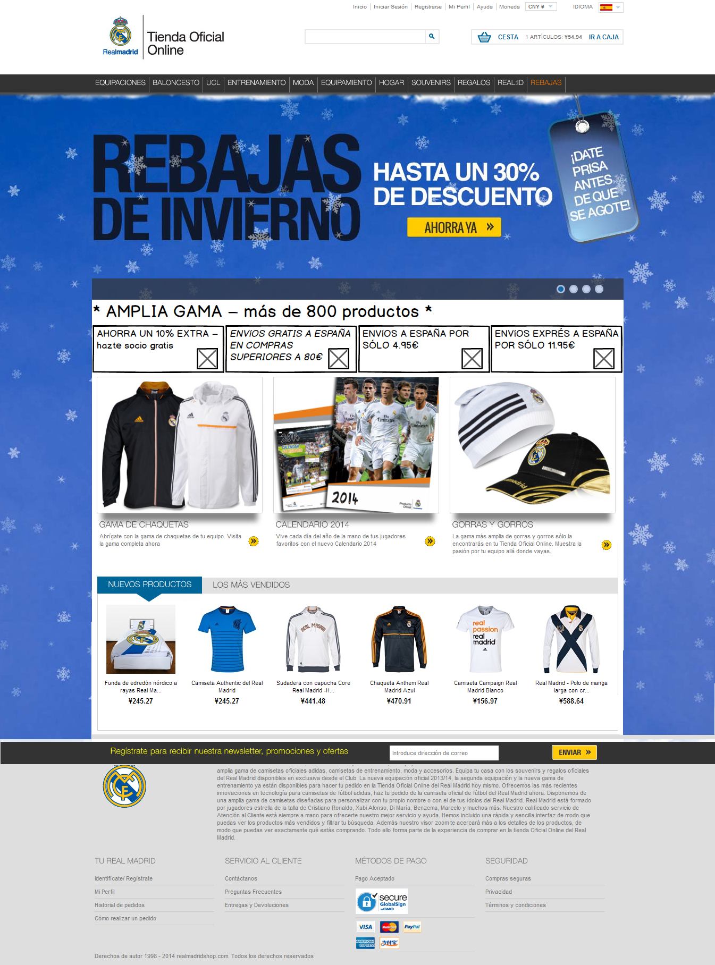

## Appendix 3 – Chinese Homepage wireframe

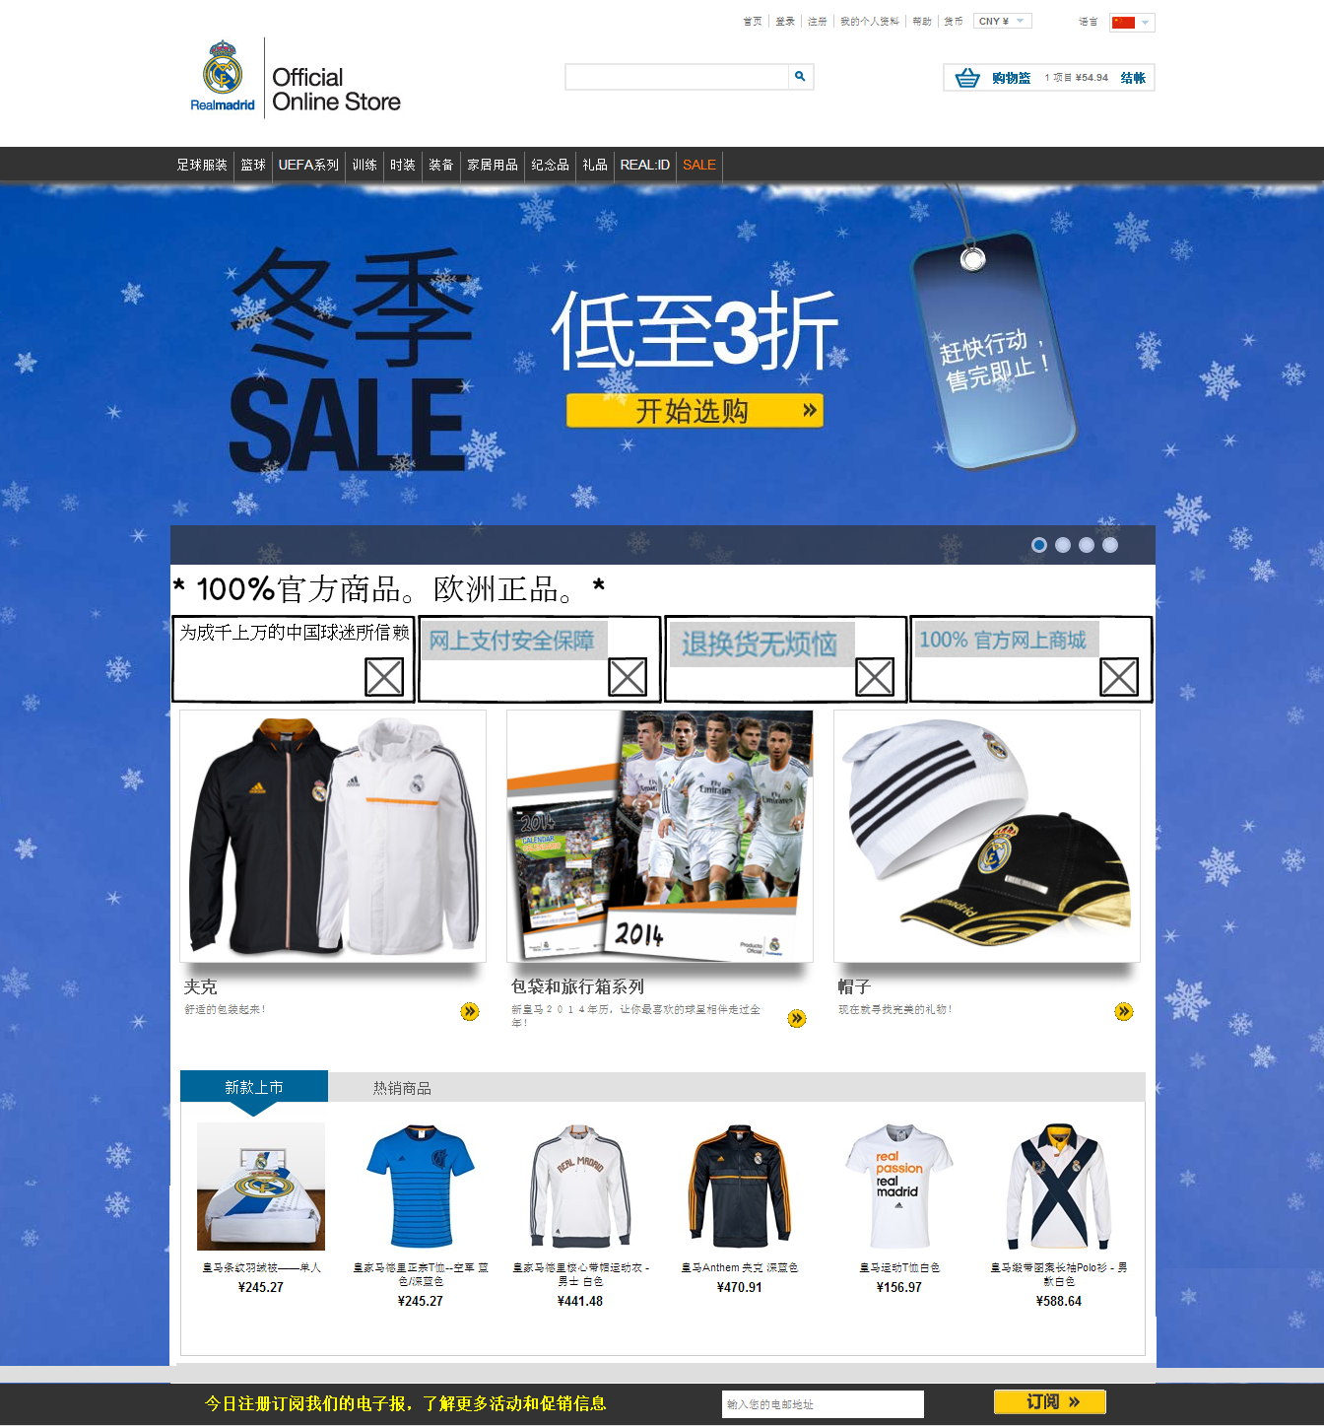

## Appendix 4 – Product page wireframe



## Appendix 5 – Lightbox wireframe

